**Release Notes**

**Revision History**

|  |  |  |  |
| --- | --- | --- | --- |
| No. | Document | Version | Date |
| 1 | 1.0-ReleaseNotes_VFQR_TestAutomation | 1.0 | 28-10-2017 |
| 2 | 2.0-ReleaseNotes_VFQR_TestAutomation | 2.0 | 7-11-2017 |
| 3 | 3.0-ReleaseNotes_VFQR_TestAutomation | 3.0 | 22-11-2017 |
| 4 | 4.0-ReleaseNotes_VFQR_TestAutomation | 4.0 | 3-12-2017 |
| 5 | 5.0-ReleaseNotes_VFQR_TestAutomation | 5.0 | 21-12-2017 |
| 6 | 6.0-ReleaseNotes_VFQR_TestAutomation | 6.0 | 04-01-2018 |
| 7 | 7.0-ReleaseNotes_VFQR_TestAutomation | 7.0 | 15-01-2018 |
| 8 | 8.0-ReleaseNotes_VFQR_TestAutomation | 8.0 | 08-02-2018 |
| 9 | 9.0-ReleaseNotes_VFQR_TestAutomation | 9.0 | 18-02-2018 |
| 10 | 10.0-ReleaseNotes_VFQR_TestAutomation | 10.0 | 27-02-2018 |
| 11 | 11.0-ReleaseNotes_VFQR_TestAutomation | 11.0 | 20-03-2018 |
| 12 | 12.0-ReleaseNotes_VFQR_TestAutomation | 12.0 | 26-03-2018 |
| 13 | 13.0-ReleaseNotes_VFQR_TestAutomation | 13.0 | 16-04-2018 |
| 14 | 14.0-ReleaseNotes_VFQR_TestAutomation | 14.0 | 02-05-2018 |
| 15 | 15.0-ReleaseNotes_VFQR_TestAutomation | 15.0 | 10-05-2018 |
| 16 | 16.0-ReleaseNotes_VFQR_TestAutomation | 16.0 | 30-05-2018 |
| 17 | 17.0-ReleaseNotes_VFQR_TestAutomation | 17.0 | 04-06-2018 |
| 18 | 18.0-ReleaseNotes_VFQR_TestAutomation | 18.0 | 03-07-2018 |
| 19 | 19.0-ReleaseNotes_VFQR_TestAutomation | 19.0 | 16-07-2018 |
| 20 | 20.0-ReleaseNotes_VFQR_TestAutomation | 20.0 | 01-08-2018 |
| 21 | 21.0-ReleaseNotes_VFQR_TestAutomation | 21.0 | 13-08-2018 |
| 22 | 22.0-ReleaseNotes_VFQR_TestAutomation | 22.0 | 03-09-2018 |
| 23 | 23.0-ReleaseNotes_VFQR_TestAutomation | 23.0 | 10-09-2018 |
| 24 | 24.0-ReleaseNotes_VFQR_TestAutomation | 24.0 | 24-09-2018 |
| 25 | 25.0-ReleaseNotes_VFQR_TestAutomation | 25.0 | 14-10-2018 |
| 26 | 31.0-ReleaseNotes_VFQR_TestAutomation | 31.0 | 2-11-2018 |

**Table of Contents**

1 Introduction 5

2 Build Details 6

2.1 Delivered Code Version 6

2.2 Open Points 6

2.3 List of Existing Features 9

2.4 List of New Features 18

2.5 Appendix 18

# Introduction

The following report aims to present the list of features along with the fixes that are deployed in the current build and available for users to use Regression pack.

# Build Details

This section describes the build details which including features available.

## Delivered Code Version

Version 11.0 is available in Jump server.

E:\Olympus\Version 11\VFQA_V11.zip

## Open Points

Below Points need to be follow before starting the execution.

* User should have Account360 view access in Seibel CRM.

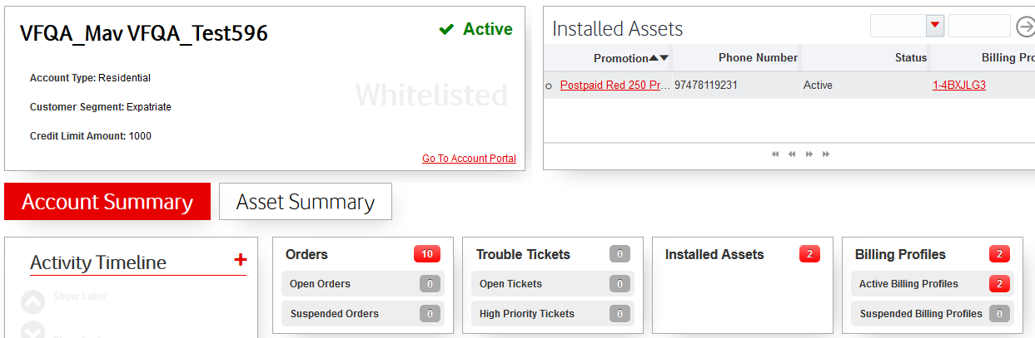

* “**Action**” and “**Bill Cycle**” Column’s need to be visible in Order line items in Seibel CRM.

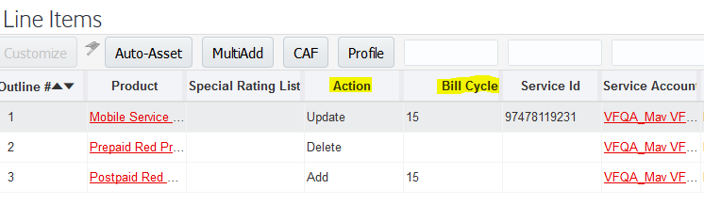

* “**Service id**” , “**Product**”, “**Asset Description”, ”Status”, “Billing Profile** “columns should be visible in Installed Assert Screen.

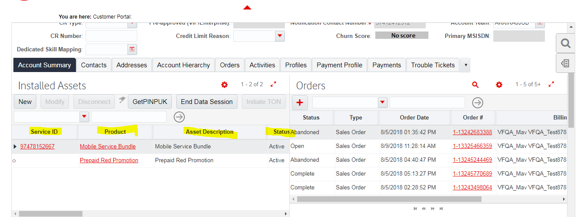

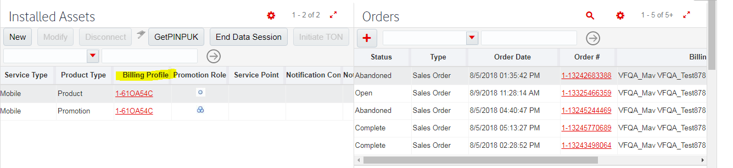

* Sales Order page should be in maximize “Click Show more” button and save as shown below.

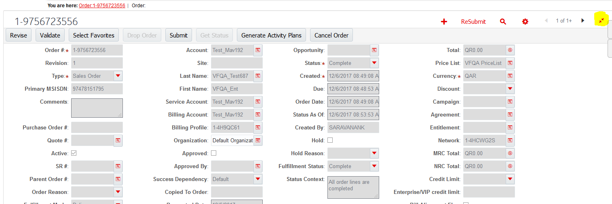

* Last name column should be visible in Contact Tab

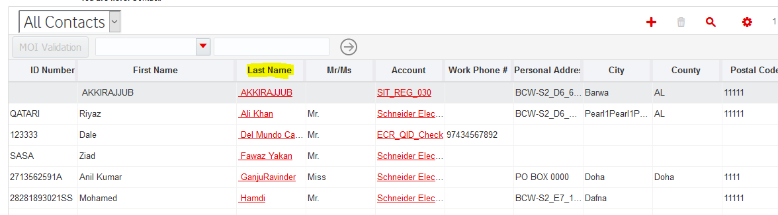

* Account number and Account name columns should be visible in accounts tab.

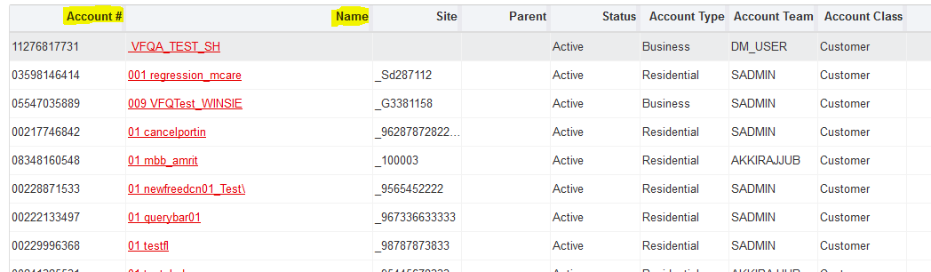

* Owner Account, Service Account, Billing Account columns should not be last and side by side under Order line Items.

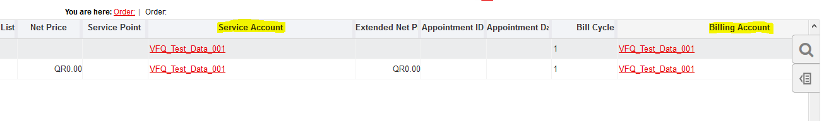

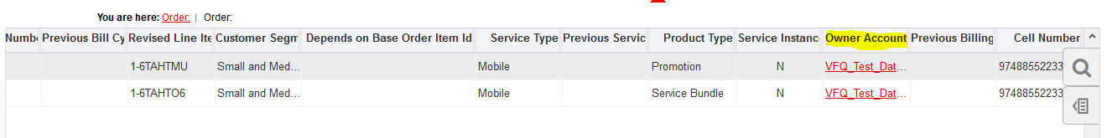

* IE Settings:

Open internet options and click on “Security” tab and click on “Reset all zones to default value”

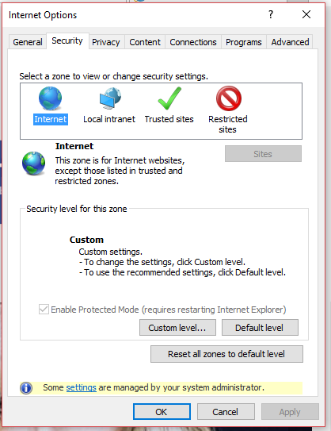

Click on Local intranet and click the chicklet to enable the protected mode

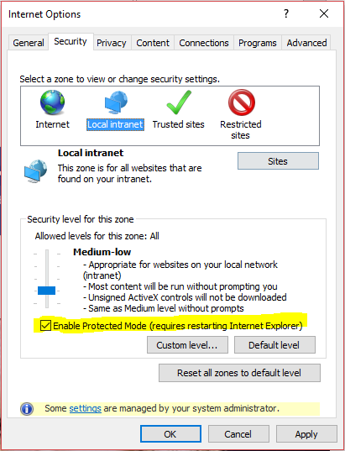

Click on Trusted sites and click the chicklet to enable the protected mode and then click Apply and Ok.

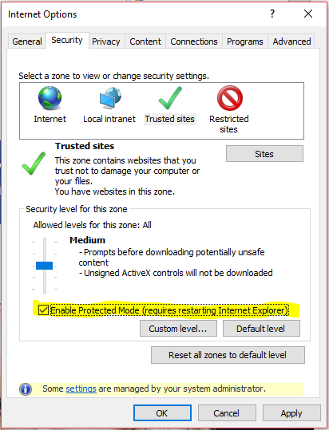

## List of Existing Features

Based Table depicts the list of existing features that did not go through any changes

1. BSS Regression test cases(CRM)

| Scenarios | Test cases | Feature | Login Inputs |
| --- | --- | --- | --- |
| ConsumerPrepaid_Provisioning | * NewCustomer * ExtCustomer | * Activation of New Prepaid Provision for New Consumer Customer. * Activation of New Prepaid Provision for Ext Consumer Customer. | * Siebel_CRM * API_RTB |
| ConsumerPostpaid_Provisioning | * NewCustomer * BlackCustomer * ExtCustomer | * Activation of New Postpaid Provision for New Consumer Customer. * Activation of New Postpaid Provision for Black Consumer Customer. * Activation of New Postpaid Provision for Ext Consumer Customer. | * Siebel_CRM * API_RTB |
| ConsumerPostpaid_Prov_OrdPay | * NewCustomer * ExtCustomer | * To Provision a New Customer with payment * To Provision an Existing Customer with payment | * Siebel_CRM * API_RTB |
| EnterprisePrepaid_Provisioning | * NewCustomer * ExtCustomer | * Activation of New Prepaid Provision for New Enterprise Customer. * Activation of New Prepaid Provision for Ext Enterprise Customer. | * Siebel_CRM * API_RTB |
| EnterprisePostpaid_Provisioning | * NewCustomer * ExtCustomer | * Activation of New Postpaid Provision for New Enterprise Customer. * Activation of New Postpaid Provision for Ext Enterprise Customer. | * Siebel_CRM * API_RTB |
| EnterprisePostpaid_Prov_OnrdPay | * NewCustomer * ExtCustomer | * To Provision a New Customer with payment * To Provision an Existing Customer with payment | * Siebel_CRM * API_RTB |
| Modify | * ConsumerPrepaid * ConsumerPostpaid * EnterprisePostpaid * EnterprisePrepaid | * Add-on Activation or Deactivation (All segments). | * Siebel_CRM |
| Suspend | * ConsumerPrepaid * ConsumerPostpaid * EnterprisePostpaid * EnterprisePrepaid | * Raise the Suspension order on Active numbers only | * Siebel_CRM |
| Resume | * ConsumerPrepaid * ConsumerPostpaid * EnterprisePostpaid * EnterprisePrepaid | * Raise the Resume order on suspended numbers only | * Siebel_CRM |
| UpgradePromotion | * ConsumerPrepaid * ConsumerPostpaid * EnterprisePostpaid * EnterprisePrepaid | * Plan Upgrade/Downgrade (All segments). | * Siebel_CRM * API_RTB |
| ConsumerMigration | * Prepaid_To_Postpaid * Postpaid_To_Prepaid | * Consumer Migration from Prepaid to Postpaid * Consumer Migration from Postpaid to Prepaid | * Siebel_CRM * API_RTB |
| EnterpriseMigration | * Prepaid_To_Postpaid * Postpaid_To_Prepaid | * Enterprise Migration from Prepaid to Postpaid * Enterprise Migration from Postpaid to Prepaid | * Siebel_CRM * API_RTB |
| Change_MSISDN | * ConsumerPrepaid * ConsumerPostpaid * EnterprisePostpaid * EnterprisePrepaid | * MSISDN change for all the Segments for an active customer. | * Siebel_CRM * API_RTB |
| SIMSwap | * ConsumerPrepaid * ConsumerPostpaid * EnterprisePostpaid * EnterprisePrepaid | * SIM Swap for all the Segments. | * Siebel_CRM * API_RTB |
| TransferOfService | * New Account * Existing Account | * Transfer of service to a new account * Transfer of service to an existing account | * Siebel_CRM * API_RTB |
| Barring | * Consumer Prepaid * Consumer Postpaid * Enterprise Postpaid * Enterprise Prepaid | * User Initiating Barring by raising Modify Order + Validation (Call) | * Siebel_CRM |
| UnBarring | * Consumer Prepaid * Consumer Postpaid * Enterprise Postpaid * Enterprise Prepaid | * User Initiating UnBarring by raising Modify Order + Validation (Call) | * Siebel_CRM |
| ModifySmartLimit | * ConsumerPostpaid | * Modify the spend limit using vanilla flow | * Siebel_CRM |
| Discounts | * PlanDiscount * AddonDiscount | * Plan level discount can be raise for postpaid customers * Addon level discount can be raise. | * Siebel_CRM |
| Disconnection | * ConsumerPrepaid * ConsumerPostpaid * EnterprisePostpaid * EnterprisePrepaid | * Raise the Disconnect order on Active numbers only | * Siebel_CRM |
| BillPayment | * CRM level | * Doing a cash payment form CRM for an active customer. | * Siebel_CRM |
| Trouble Ticket | * TT | * Trouble ticket for change credit limit(creation and closure) | * Siebel_CRM |
| TransferOfOwnership_C2C | * New Account * Existing Account | * Transfer of all services to a new account (Consumer-Consumer) * Transfer of all services to an existing account (Consumer-Consumer) | * Siebel_CRM |
| ConsumerPostpaid_GuidedJourney | * NewCustomer * ExtCustomer | * Activation of New Postpaid Provision for New Consumer Customer via guided journey. * Activation of New Postpaid Provision for Ext Consumer Customer via guided journey. | * Siebel_CRM * API_RTB |
| SIMSwap_Guided_Journey | * ConsumerPrepaid * ConsumerPostpaid * EnterprisePostpaid   EnterprisePrepaid | * SIM Swap for all the Segments via guided journey. | * Siebel_CRM |
| SIMSwap_Global_Search | * ConsumerPrepaid * ConsumerPostpaid * EnterprisePostpaid   EnterprisePrepaid | * SIM Swap for all the Segments via SIM Swap Global Search button. | * Siebel_CRM |
| ModifySmartLimit_Acc360 | * ConsumerPostpaid | * Modify the spend limit using Modify Smart Limit Account 360 button | * Siebel_CRM |
| UpgradePromotion_Acc360 | * ConsumerPrepaid * ConsumerPostpaid * EnterprisePostpaid * EnterprisePrepaid | * Plan Upgrade/Downgrade (All segments) from account 360 view | * Siebel_CRM * API_RTB |
| Account360view | * ConsumerPrepaid * ConsumerPostpaid * EnterprisePostpaid * EnterprisePrepaid | * Verifying content in Account 360 view. | * Siebel_CRM |
| OpenUI_AccesRrights_6Segments  (6 segment verification for the segment selected)   |  | | --- | | Royal | | Black | | VVIP | | VIP | | Qatari | | FrontOffice | | * GlobalSearchMSISDN * GlobalSearchContact * AssertMSISDNQuery * GuidedSIMSwap * AccountNameQuery * AccountNumberQuery   ContactIDQuery | * To verify Global search MSISDN for Customer segment selected. * To verify Global Search Contact for Customer segment selected. * To verify Assert MSISDN Query for Customer segment selected. * To verify Guided SIM Swap for Customer segment selected. * To verify Account Name Query for Customer segment selected. * To verify Account Number Query for Customer segment selected. * To verify Contact ID Query for Customer segment selected. | * Siebel_CRM |
| Change_PrimaryNumber | * ConsumerPostpaid * EnterprisePostpaid | * Primary Number change for all the Segments for an active customer. | * Siebel_CRM |
| TransferOfOwnership_E2E | * New Account * Existing Account | * Transfer of all services to a new account (Enterprise-Enterprise) * Transfer of all services to an existing account (Enterprise-Enterprise) | * Siebel_CRM |
| TransferOfOwnership_C2E | * New Account * Existing Account | * Transfer of all services to a new account (Consumer- Enterprise) * Transfer of all services to an existing account (Consumer- Enterprise) | * Siebel_CRM |
| TransferOfOwnership_E2C | * New Account * Existing Account | * Transfer of all services to a new account (Enterprise -Consumer) * Transfer of all services to an existing account (Enterprise -Consumer) | * Siebel_CRM |
| Activities | * Create * Close | * Creating a specific activity * Closing a specific activity | * Siebel_CRM |
| LanguageChange | * ExtCustomer | * Language Change for Existing customer | * Siebel_CRM |
| CreditLimit | * ExtCustomer | * Credit Limit Set for Existing customer | Siebel_CRM |
| Cancel_Order | * Account_Level * Order_Level | * Cancellation of Order using Account Number * Cancellation of Order using Order Number | * Siebel_CRM |
| Cancel_Pending_Order | * Account Level * Order Level | * Cancelling the Order Using Account No * Cancelling the pending order using Order Id | * Siebel_CRM |
| Siebel_NBO | * Accept * Reject * Interested | * Accepting the NBO * Rejecting the NBO * Interested in NBO | * Siebel_CRM |
| Suspend_Account | * Suspend_Account | * Suspending all the MSISDN’s Using Account Number | * Siebel_CRM |
| Get_PUK | * Get_PUK | * Activating PIN for SIM Number | * Siebel_CRM |
| OrderReplicationleProvisioning | * Existing | * Replicating the existing order for existing customer | * Siebel_CRM |
| Adjustments_BillingProfile | * Debit * Credit | * Billing profile Adjustments * Billing profile Adjustments | * Siebel_CRM |
| Adjustments_Bill | * Debit * Credit | * Bill Adjustments * Bill Adjustments | * Siebel_CRM |
| Adjustments_Item | * Debit * Credit | * Item Level Adjustments * Item Level Adjustments | * Siebel_CRM |
| SharedBundleProvisioning | * NewActivation | * Shared Bundle Activation for new customer | * Siebel_CRM |
| SharedBundleDisconnection | * MSISDNLevel * AccountLevel | * Shared Bundle Disconnection using MSISDN * Shared Bundle Disconnection using Account | * Siebel_CRM |
| ModifySpendlimit | * EnterprisePostpaid | * Modifying Spend Limit for Enterprise Customer | * Siebel_CRM |

1. BSS Regression test cases (BRM)

| Scenarios | Test cases | Feature | Login Inputs |
| --- | --- | --- | --- |
| BillGeneration_AccountLevel | * SingleAccount * MultipleAccount | * Bill Generation for all services (single and multiple billing profiles) | * BRM_Putty * BRM_DB |
| DunningProcess | * ExtCustomer | * To Process Dunning for the Existing customer based on dunning calendar | * Siebel_CRM * BRM_Putty * BRM_DB |
| DunningAction | * ExtCustomer | * To perform dunning actions | * Siebel_CRM |
| CollectionExit | * ExtCustomer | * Exits from the collections | * Siebel_CRM |
| InvoiceToPDF_Generation | * SingleAccount * MultipleAccount | * PDF Generation for all services (single and multiple billing profiles) | * BRM_Putty * BRM_DB * PJM_APP |
| BillGeneration_BillingProfile | * SingleAccount * MultipleAccount | * Bill Generation for all services (using bill Profile) | * BRM_Putty * BRM_DB |

1. BSS Regression test cases (Consumer Products)

| Scenarios | Test cases | Feature | Login Inputs |
| --- | --- | --- | --- |
| PearlMobile_Provisioning | * NewCustomer | * Pearl Mobile Provisioning for new customer | * Siebel_CRM |
| PearlData_Provisioning | * NewCustomer | * Pearl Data Provisioning for new customer | * Siebel_CRM * OSM_APP |

1. BSS Regression test cases (Enterprise Products)

| Scenarios | Test cases | Feature | Login Inputs |
| --- | --- | --- | --- |
| ConsumerFixedLine_Provision | * NewCustomer | * Consumer Fixed Line Provisioning for new customer | * Siebel_CRM * OSM_APP |
| EnterpriseFixedLine_Provision | * NewCustomer | * Enterprise Fixed Line Provisioning for new customer | * Siebel_CRM |
| SIPT | * NewCustomer | * Activation of New SIPT Provision for New Enterprise Customer | * Siebel_CRM |
| FL_ONT_CPE_Replacement | * ONT * ONT_CPE * CPE | * Replacing ONT by raising Modify Order * Replacing ONT and CPE by raising Modify Order * Replacing CPE by raising Modify Order | * Siebel_CRM * OSM_APP |
| HomeMove | * NewCustomer | * Home Move Order for new Customer | * Siebel_CRM * OSM_APP |
| DAPN_Provisioning | * NewCustomer * ExtCustomer | * DAPN Provisioning for new customer * DAPN Provisioning for Existing customer | * Siebel_CRM |
| UpgradePromotion_DAPN | * DAPN | * Upgrading the Promotion for DAPN Customer | * Siebel_CRM |
| FL_Disconnect | * FL_Disconnect | * Disconnecting the MSISDN (Fixed Line) | * Siebel_CRM |
| ETHERNET | * NewCustomer | * Provisioning a New Customer | * Siebel_CRM |
| MPLS | * NewCustomer | * Provisioning a New Customer | * Siebel_CRM |
| LEASEDLINE | * NewCustomer | * Provisioning a New Customer | * Siebel_CRM |
| IPLC | * NewCustomer | * Provisioning a New Customer | * Siebel_CRM |
| SIPT | * NewCustomer | * Activation of New SIPT Provision for New Enterprise Customer (Enhanced code for NLS Connectivity Environment) | * Siebel_CRM |

1. Mobile test cases (Usages, USSD, Calls)

| Scenarios | Test cases | Feature | Login Inputs |
| --- | --- | --- | --- |
| LocalCall | * LocalCall | * Performing Local Call and validating the buckets |  |
| InternationalCall | * InternationalCall | * Performing International Call and validating the buckets |  |
| LocalSMS | * LocalSMS | * Performing Local SMS and validating the buckets |  |
| InternationalSMS | * InternationalSMS | * Performing International SMS and validating the buckets |  |
| BalanceCheck | * BalanceCheck | * Balance Check Notification |  |
| Recharge | * Recharge | * Recharge via Short code |  |
| FlexBalanceCheck | * FlexBalanceCheck | * Flex Balance Check Notification |  |
| ProductInfo_USSD | * ProductInfo_USSD | * Product Info via USSD menu |  |
| ProductActivation_USSD_Prepaid | * ProductActivation_USSD_Prepaid | * Product Activation via USSD for Prepaid |  |
| SetUpMobileDevice | * SetUpMobileDevice | * Restart Mobile after provisioning and configure the SMSC center |  |
| Postpaid_USSD_Act-DeAct | * Activation * Deactivation | * Product Activation via USSD for postpaid customer * Product Deactivation via USSD for postpaid customer | * Siebel_CRM |
| Prepaid_Happy_Offers_USSD | * **Prepaid_Happy_Offers_USSD** | * Activation of Happy Offers Via USSD | * Siebel_CRM |
| BillEnquiry_USSD | * **BillEnquiry_USSD** | * Bill Payment Via USSD | * Siebel_CRM |
| BillPayment_USSD | * **BillPayment_USSD** | * Bill Enquiry Via USSD | * Siebel_CRM |

1. MCare Regression test cases

| Scenarios | Test cases | Feature | Login Inputs |
| --- | --- | --- | --- |
| MCare_VerifyPlanName | * MCare_VerifyPlanName | * Verifying plan Name Via MCare | * Siebel_CRM * OSM_APP |
| MCare_BillEnquiry | * MCare_BillEnquiry | * BillEnquiry Via MCare | * Siebel_CRM |
| Mcare_ProdActivation | * Mcare_ProdActivation | * Product Activation Via MCare | * Siebel_CRM |
| Mcare_DeActivation | * Mcare_DeActivation | * Product Deactivation Via MCare | * Siebel_CRM |
| Mcare_Post_FlexVerify | * Mcare_Post_FlexVerify | * Flex Balance Verification Via Mcare |  |
| Mcare_Pre_FlexVerify | * Mcare_Pre_FlexVerify | * Flex Balance Verification Via Mcare |  |
| Mcare_Post_ProdActivation | * Mcare_Post_ProdActivation | * Postpaid Product Activation Via MCare | * Siebel_CRM |
| Mcare_Post_ProdDeActivation | * Mcare_Post_ProdDeActivation | * Postpaid Product Deactivation Via MCare | * Siebel_CRM |
| Mcare_BillPayments | * Payment_Self | * Self Bill Payment | * Siebel_CRM |
| Mcare_VerifyBuckets | * Mcare_VerifyBuckets | * Verification Of Buckets in Mcare App | * Siebel_CRM |
| Mcare_Cookies | * Mcare_Cookies | * Cookies balance check in MCare | * Siebel_CRM |
| ModifySpendlimit | * ModifySpendlimit | * Modify spend limit | * Siebel_CRM * OSM_APP |
| Mcare_SelfRecharge | * Credit_recharge * Flex_recharge * INTL_recharge * Internet_recharge * Combo_recharge * Red_recharge | * Self-Recharge Via MCare with Credit as Input * Self-Recharge Via MCare with Flex as Input * Self-Recharge Via MCare with INTL as Input * Self-Recharge Via MCare with Internet as Input * Self-Recharge Via MCare with Combo as Input * Self-Recharge Via MCare with Red as Input |  |
| Mcare_OtherRecharge | * Credit_recharge * Flex_recharge * INTL_recharge * Internet_recharge * Combo_recharge * Red_recharge | * Self-Recharge Via MCare with Credit as Input * Self-Recharge Via MCare with Flex as Input * Self-Recharge Via MCare with INTL as Input * Self-Recharge Via MCare with Internet as Input * Self-Recharge Via MCare with Combo as Input * Self-Recharge Via MCare with Red as Input |  |
| Mcare_BillPayments | * Payment_Self * Payment_Others | * Self-Bill payment via MCare * Others Bill payment via MCare | * Siebel_CRM |

## List of New Features

Based Table depicts the list of features that are added during this release

1. BSS Regression test cases(CRM)

| Scenarios | Test cases | Feature | Login Inputs |
| --- | --- | --- | --- |
| New Consumer FL | * NewCustomer | * Activation of New FL fiber Provision for New Consumer Customer | * Siebel_CRM * OSM_APP |
| New Enterprise FL | * NewCustomer | * Activation of New FL fiber Provision for New Enterprise Customer | * Siebel_CRM * OSM_APP |
| IPTV Consumer FL | * NewCustomer | * Activation of New IPTV FL fiber Provision for New Consumer Customer | * Siebel_CRM * OSM_APP |
| IPTV Enterprise FL | * NewCustomer | * Activation of New IPTV FL fiber Provision for New Enterprise Customer | * Siebel_CRM * OSM_APP |

## Appendix

| Document Name | Key Points | Attachment |
| --- | --- | --- |
| Application Installation Manual | * Document describes the steps that need to be followed at the time of installation. |  |
| VFQA_TestDesign Manual | * Document describes the List of use case types with annotation templates * Usage types which has template, tool will auto populate. |  |
| User Execution Manual | * Document describes the steps to run the framework. |  |
| Mobile Usage Setup | * Document describes the installation setup for Mobile usage Scenarios. |  |